# INTRODUCTION:

* 1. OVER VIEW

About the housing prices “ ANALYSING HOUSING PRICES IN METROPOLITAN CITIES OF INDIA”.

* 1. PURPOSE

USE:* More and More people in India are looking to buy residential Properties period between RS 1-2 crore.

*The luxury housing regment in India’s major cities is experiencing a significant boom due to rising incomes and aspirations.

ACHIVEMENT : * India houseprices grew 2.7% YOY in June 2023. An increase of 1.8% YOY in the previous quarter.

*House Price data reached an all time high of 30.6% in March 2011 and a record low of 11.4%in septemper 2020.

# PROBLEM DEFINITION AND DESIGN THINKING

2.1 Empathy Map

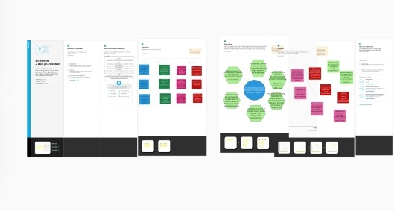

2.2 Brain stosmping Map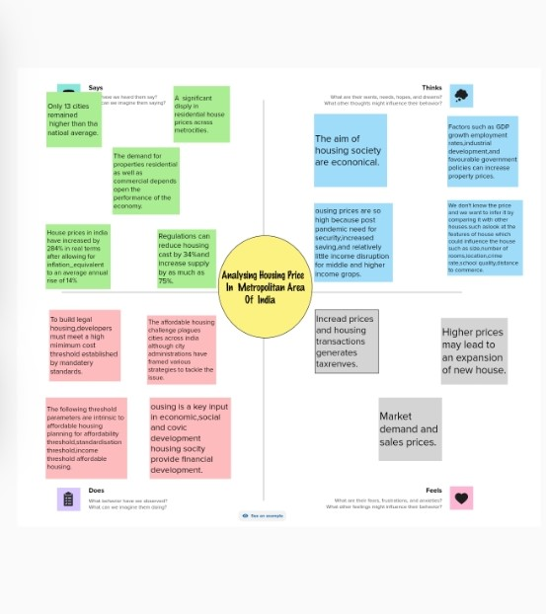

# RESULT

GRAPH – TOTAL ( 9 GRAPH)

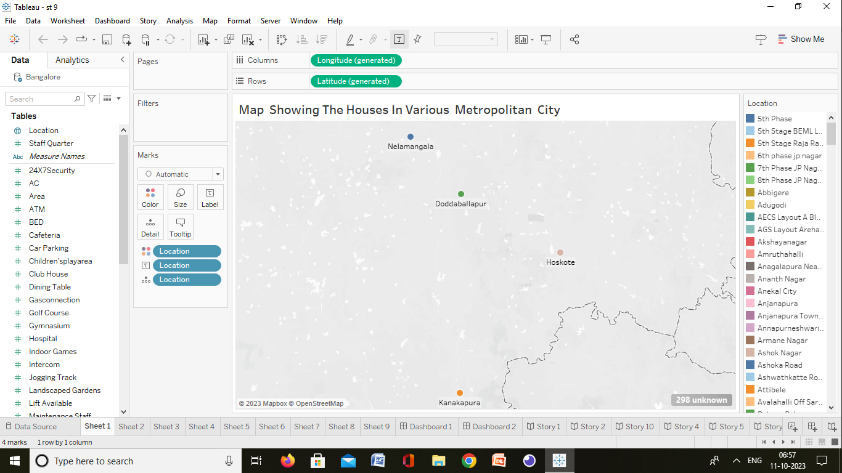

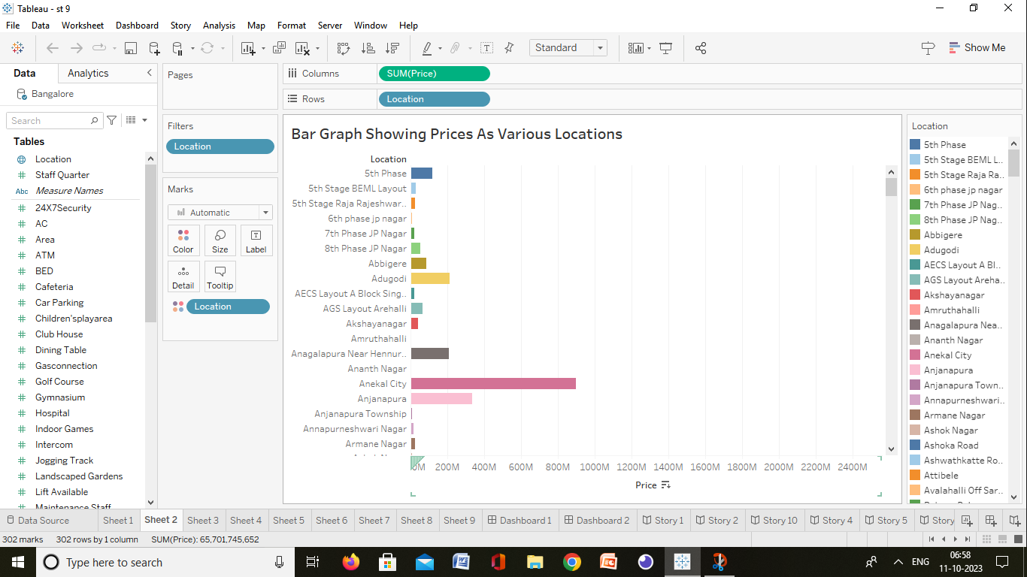

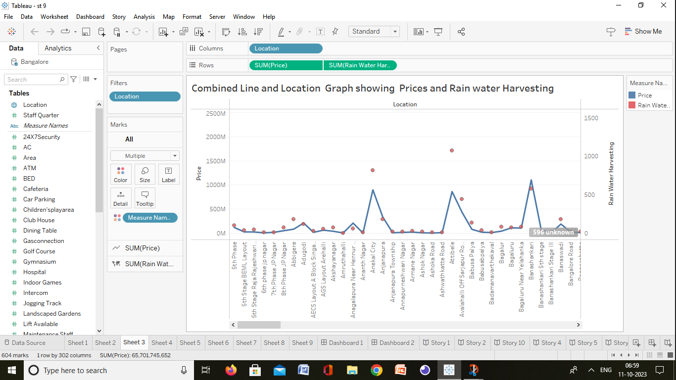

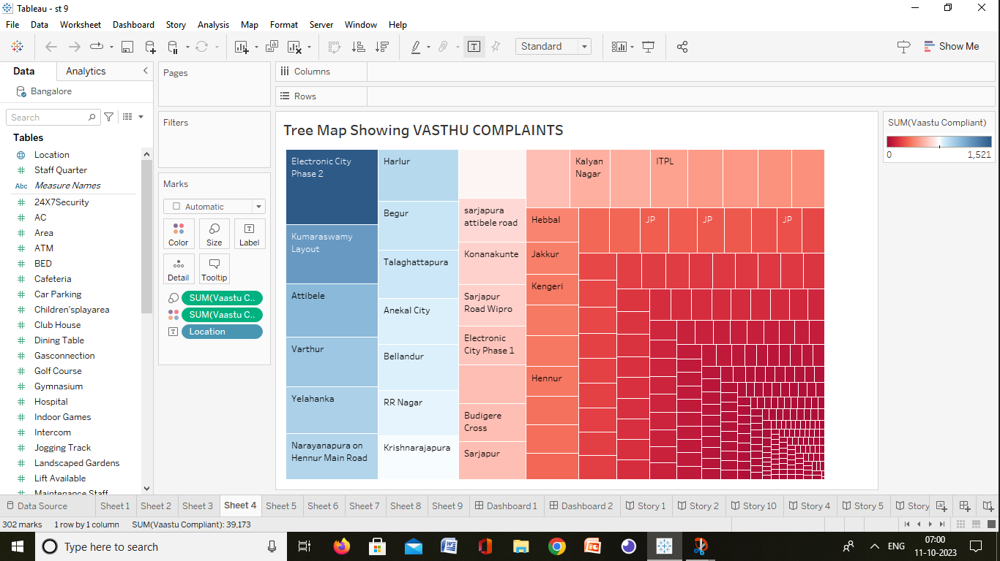

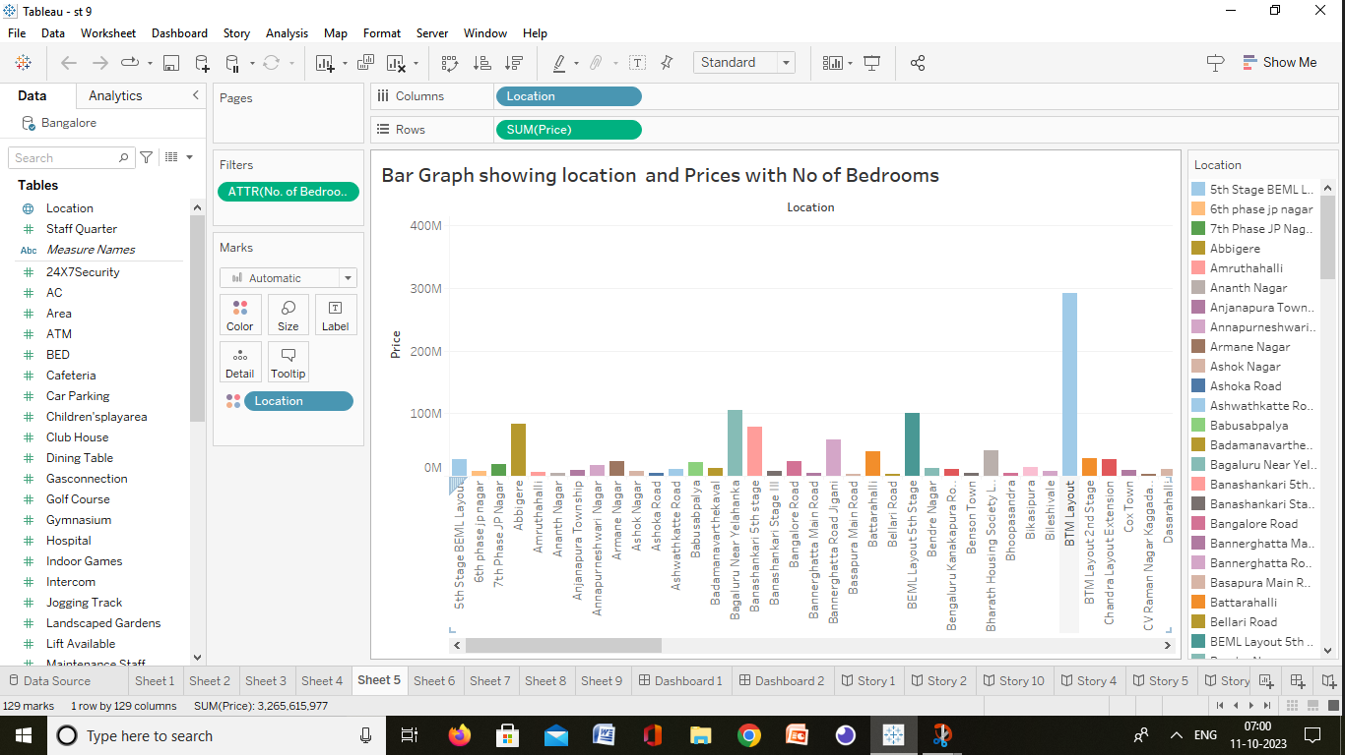

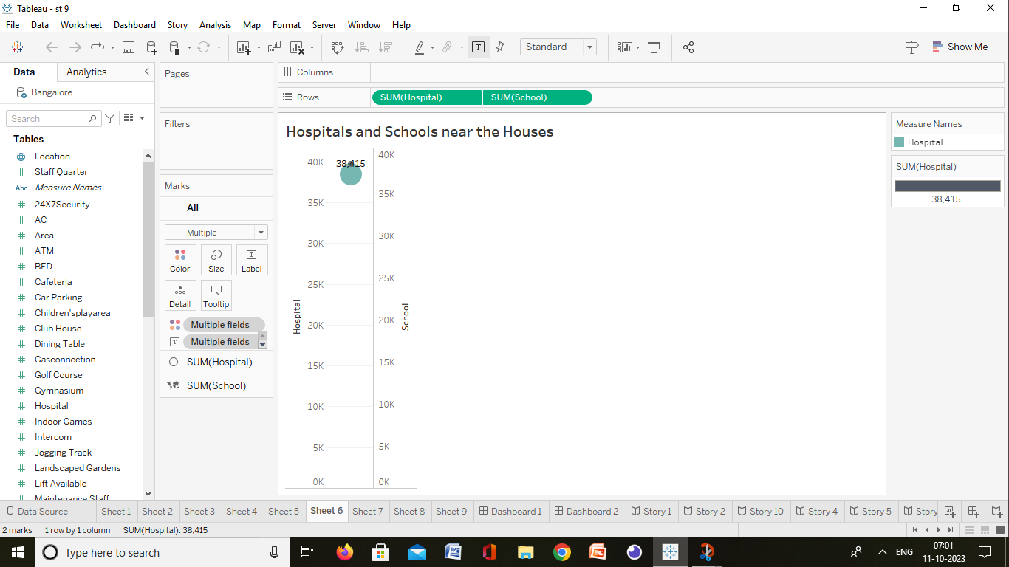

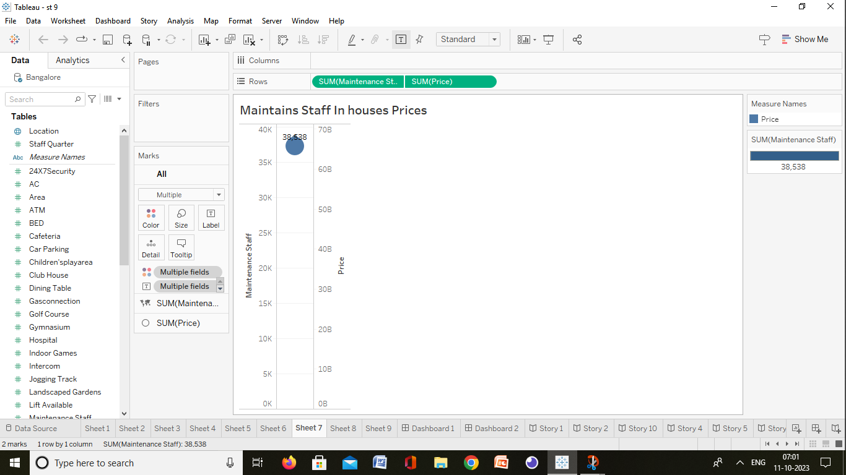

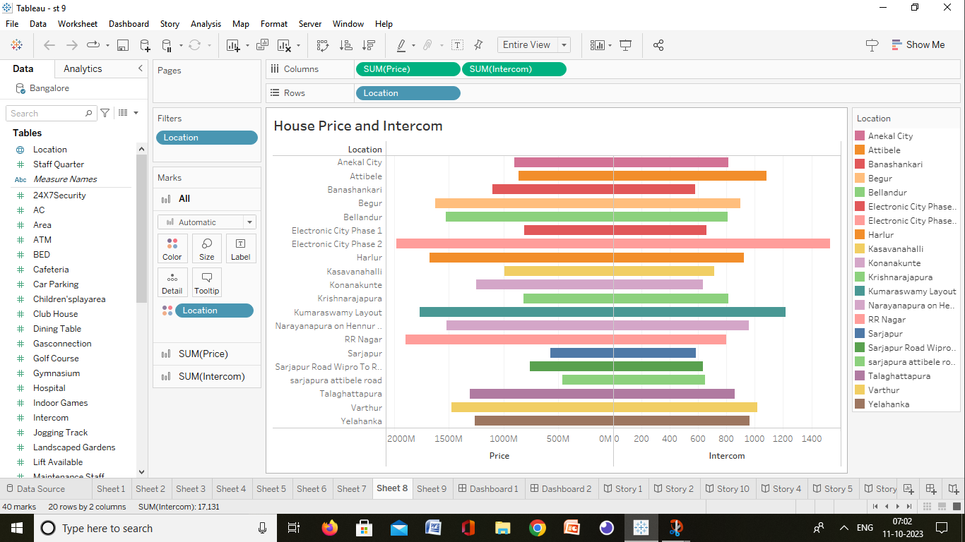

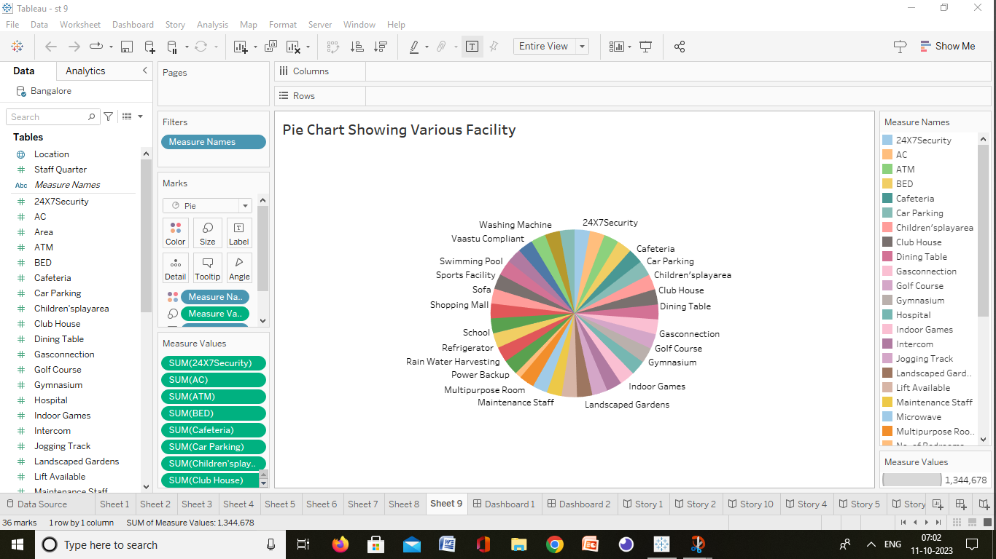

# ADVANTAGES:

*Metropolitan areas are in general productive than smaller urban agglomerations and rural areas.

* It can send data in both directions at the some times.

# DISADVANTAGES:

*High cost of rent and food .

* Busy towns or cities can feel crowded and may mean you feel more stress or pressure.

# APPLICATIONS:

*Residential property prices rise by 6% in Q2 2023.

*India’s booming commercial and industrial sectors.

# CONCLUSION:

*Help the developer determine the selling price of a house and can help the customer to arrange the right time to purchase a house.

# FUTURE SCOPE:

*India’s real estate sector is expected to expand to USD 5.8 trillion or USD 833 billion by 2047.

* Compound annual growth rate of 9.2%during the period between 2023to 2028.